
OFFICE OF THE PRINCIPAL

JANATA COLLEGE SERFANGURI
P.O.- SERFANGURI, - 783346 DIST.- KOKRAJHAR, BTR. (ASSAM)
M-94350-26695, 0361-291905, e-mail: principal_jcs@rediffmail.com :: Website: www.janatacollege.co.in

Letter No. JCS/SUM/VAC/2025/01 Date.30/06/2025
From,
Mr. Bitoray Brahma, M.A. Principal, i/c
NOTICE
This is to inform all the teaching staff, and students of Janata College, Serfanguri that the classes shall remain closed for Summer Vacation with effect from 1st July to 30th July 2025, as per the academic calendar and notification circulated by Bodoland University. Accordingly, all students and faculty members are requested to turn up to the college for their respected duties from 31st July 2025 after the vacation.
However, as for the non-teaching staff the normal duty of official works will continue as usual throughout the summer vacation.
Normal classes will resume from 31st July 2025 (Thursday).
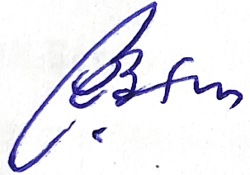
Principal
Janata College, Serfanguri


